Guide to Activating Tennis Floodlights

Floodlights can now be activated online from your PC, laptop, tablet, mobile phone. The cost is £6 per hour per court.
NB: Lights can only be added and paid for on the day of the booking in question.
How to activate the lights online:
- Login to the online court booking system
- Once logged in, go to MAIN MENU and then select MY BOOKINGS.
- Find the booking in question and on the day of your booking, the booking will have an option to MANAGE LIGHTS.

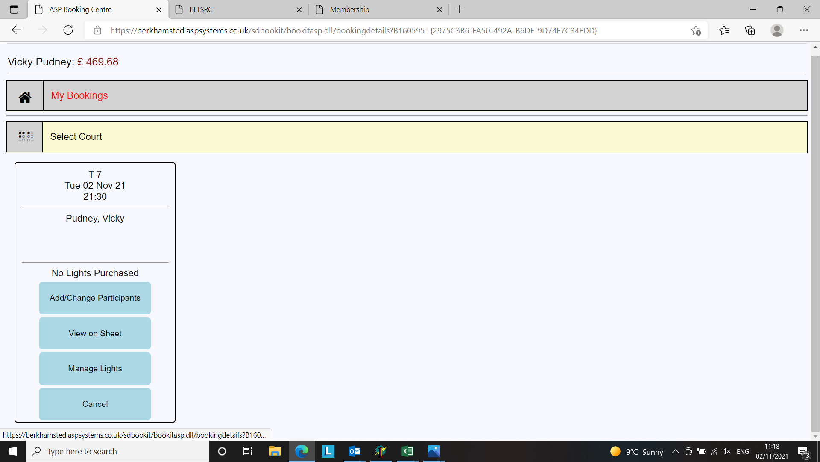

- First select the START time for the lights to come on.

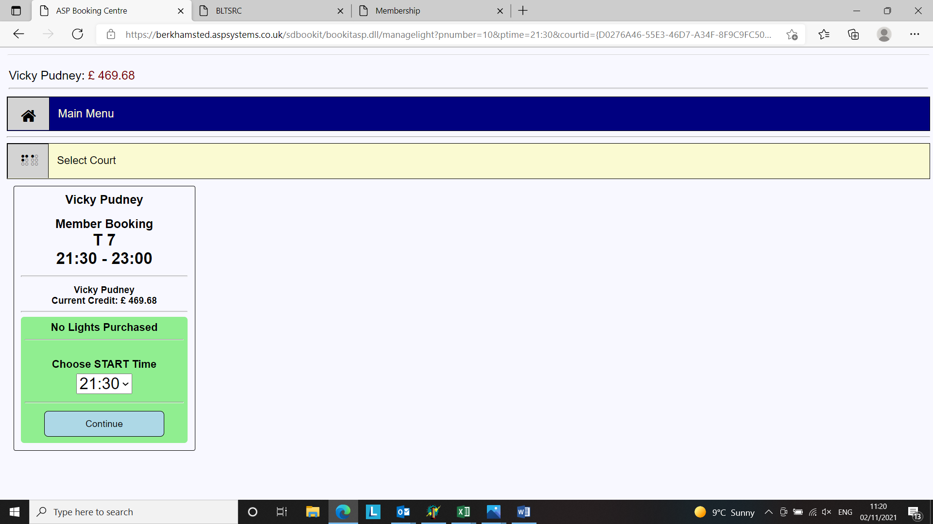

- Next, select the OFF time for the lights. NB: Please ensure that you allocate enough time for your game to avoid the lights going off and you still needing more time. If you want to put them back on again once they have gone off then there is a 15-minute cooling down period before they can be re-activated on all courts except for 7-9 which are now LED.
- Lights can be booked for 5-minute increments.
- Select the length of time you wish to have the lights on for.
- Then click BUY LIGHTS.
- The lights will then come on at your scheduled time.
- If you find you finish your game before the lights are due to go out you can select PAUSE LIGHTS on the online booking and they will switch off. At the moment there is no auto-refund to member accounts for this but something we would like to add in the future but it will save energy!

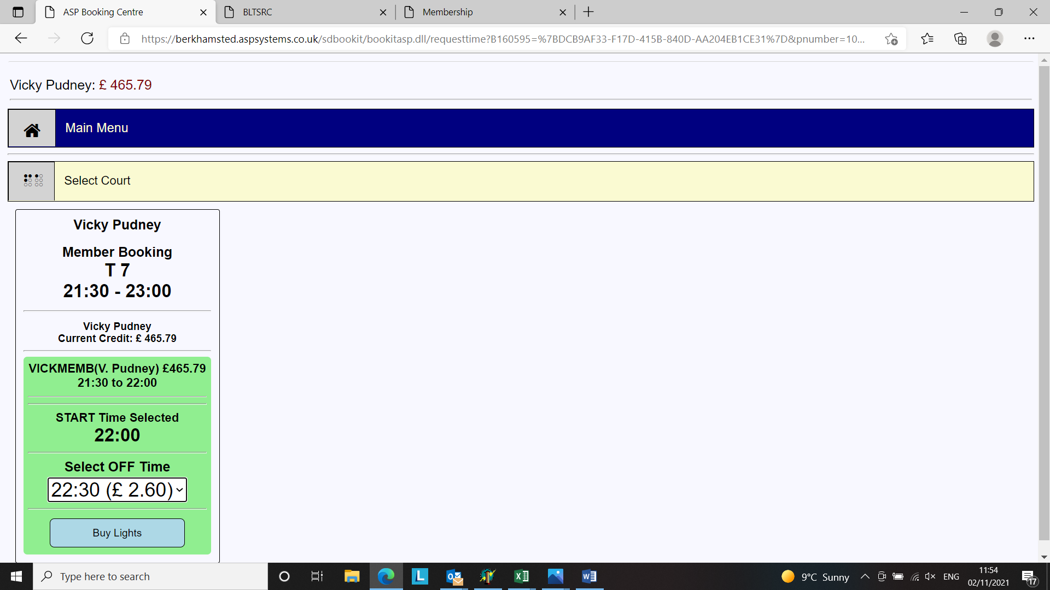

Points to note:
- Floodlights cost £6 per hour per court.
- Lights are not available on court 6b.
- You will need to have credit on your account in order to be able to activate the lights. This can be done via the TOP UP CREDIT option which is found on the MY BOOKINGS dropdown once you have logged in to your account.
- Floodlights can be activated and paid for online by any member listed on the court booking in question. It is not possible to manage the lights online on a booking which does not include your name.
- Lights can be booked for immediate use from a mobile phone at the club.
- Lights can be cancelled (online only and not via kiosk) to save them being wasted if you finish playing before the lights are due to go out. Select PAUSE LIGHTS on the booking in question to turn the lights off. There is also a RESUME button if you want to put the lights back on again eg – in the scenario where there is a rain shower. Note the 15-minute bulb cool down will still apply.
- Lights can also be pre-programmed to come on at a specific time e.g. if you have a 7pm-8pm booking, you can set the lights to come as needed before you leave home. It is also possible to set the lights to come on part way through your booking if you do not need the lights at the start of your booking e.g. you can pre-book them to come on 30 minutes into your booking.
- It is possible – should you wish to do so – for more than one member listed on the booking to activate, and pay for, part of the session. This would require each member to book their part of the session individually

